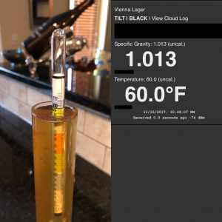

**DEPARTMENT** **OF** **COMPUTER** **SCIENCE** **&** **ENGINEERING** **THE** **UNIVERSITY** **OF** **TEXAS** **AT** **ARLINGTON**

**DETAILED** **DESIGN** **SPECIFICATION** **CSE** **4317:** **SENIOR** **DESIGN** **II** **FALL** **2020**

**TEAM** **HYDRO** **BLUETOOTH** **HYDROMETER**

**ANDREW** **DUONG** **REBECCA** **BYUN** **GAM** **B.** **GARBUJA** **RYAN** **TYLER**

**REVISION** **HISTORY**

|  |  |  |  |
| --- | --- | --- | --- |
| **Revision** | **Date** | **Author(s)** | **Description** |
| 0.1 | 09.18.2020 | AD | document creation |
| 0.2 |  |  | complete draft |
| 0.3 |  |  | release candidate 1 |
| 1.0 |  |  | ofﬁcial release |
| 1.1 |  |  | added design review requests |

**CONTENTS**

**1** **Introduction** **5**

**2** **System** **Overview** **5**

**3** **X** **Layer** **Subsystems** **6** 3.1 Layer Hardware . . . . . . . . . . . . . . . . . . . . . . . . . . . . . . . . . . . . . . . . . . . . . 6 3.2 Layer Operating System . . . . . . . . . . . . . . . . . . . . . . . . . . . . . . . . . . . . . . . . 6 3.3 Layer Software Dependencies . . . . . . . . . . . . . . . . . . . . . . . . . . . . . . . . . . . . . 6 3.4 Subsystem 1 . . . . . . . . . . . . . . . . . . . . . . . . . . . . . . . . . . . . . . . . . . . . . . . 6

**4** **Y** **Layer** **Subsystems** **8** 4.1 Layer Hardware . . . . . . . . . . . . . . . . . . . . . . . . . . . . . . . . . . . . . . . . . . . . . 8 4.2 Layer Operating System . . . . . . . . . . . . . . . . . . . . . . . . . . . . . . . . . . . . . . . . 8 4.3 Layer Software Dependencies . . . . . . . . . . . . . . . . . . . . . . . . . . . . . . . . . . . . . 8 4.4 Subsystem 1 . . . . . . . . . . . . . . . . . . . . . . . . . . . . . . . . . . . . . . . . . . . . . . . 8

**5** **Z** **Layer** **Subsystems** **10** 5.1 Layer Hardware . . . . . . . . . . . . . . . . . . . . . . . . . . . . . . . . . . . . . . . . . . . . . 10 5.2 Layer Operating System . . . . . . . . . . . . . . . . . . . . . . . . . . . . . . . . . . . . . . . . 10 5.3 Layer Software Dependencies . . . . . . . . . . . . . . . . . . . . . . . . . . . . . . . . . . . . . 10 5.4 Subsystem 1 . . . . . . . . . . . . . . . . . . . . . . . . . . . . . . . . . . . . . . . . . . . . . . . 10

**6** **Appendix** **A** **12**

**LIST** **OF** **FIGURES**

1 System architecture . . . . . . . . . . . . . . . . . . . . . . . . . . . . . . . . . . . . . . . . . . . 5 2 Example subsystem description diagram . . . . . . . . . . . . . . . . . . . . . . . . . . . . . . 6 3 Example subsystem description diagram . . . . . . . . . . . . . . . . . . . . . . . . . . . . . . 8 4 Example subsystem description diagram . . . . . . . . . . . . . . . . . . . . . . . . . . . . . . 10

**LIST** **OF** **TABLES**

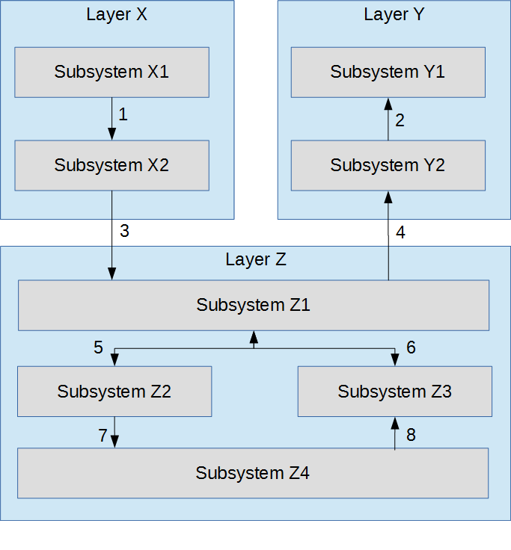

**1** **INTRODUCTION**

Your introduction should provide a brief overview of the product concept and a reference to the require-ment speciﬁcation and architectural design documents in 1 or 2 paragraphs. The purpose is to provide the reader with the location of relevant background material that lead to the design details presented in this document.

**2** **SYSTEM** **OVERVIEW**

This section should reintroduce the full data ﬂow diagram from the architectural speciﬁcation, and discuss at a high level the purpose of each layer. You do not need to include a subsection for each layer, a 1 - 2 paragraph recap is sufﬁcient.

Figure 1: System architecture

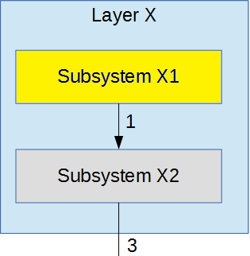

**3** **X** **LAYER** **SUBSYSTEMS**

In this section, the layer is described in terms of the hardware and software design. Speciﬁc imple-mentation details, such as hardware components, programming languages, software dependencies, op-erating systems, etc. should be discussed. Any unnecessary items can be ommitted (for example, a pure software module without any speciﬁc hardware should not include a hardware subsection). The organization, titles, and content of the sections below can be modiﬁed as necessary for the project.

**3.1** **LAYER** **HARDWARE**

A description of any involved hardware components for the layer. For example, if each subsystem is a software process running on an embedded computer, discuss the speciﬁcs of that device here. Do not list a hardware component that only exists at the subsystem level (include it in the following sections)

**3.2** **LAYER** **OPERATING** **SYSTEM**

A description of any operating systems required by the layer. **3.3** **LAYER** **SOFTWARE** **DEPENDENCIES**

A description of any software dependencies (libraries, frameworks, etc) required by the layer. **3.4** **SUBSYSTEM** **1**

Descibe at a high level the purpose and basic design of this subsystem. Is it a piece of hardware, a class, a web service, or something else? Note that each of the subsystem items below are meant to be speciﬁc to that subystem and not a repeat of anything discussed above for the overall layer.

Figure 2: Example subsystem description diagram

**3.4.1** **SUBSYSTEM** **HARDWARE**

A description of any involved hardware components for the subsystem.

**3.4.2** **SUBSYSTEM** **OPERATING** **SYSTEM**

A description of any operating systems required by the subsystem.

**3.4.3** **SUBSYSTEM** **SOFTWARE** **DEPENDENCIES**

Adescriptionofanysoftwaredependencies(libraries, frameworks, designsoftwareformechanicalparts or circuits, etc) required by the subsystem.

**3.4.4** **SUBSYSTEM** **PROGRAMMING** **LANGUAGES**

A description of any programming languages used by the subsystem.

**3.4.5** **SUBSYSTEM** **DATA** **STRUCTURES**

A description of any classes or other data structures that are worth discussing for the subsystem. For example, data being transmitted from a microcontroller to a PC via USB should be ﬁrst be assembled into packets. What is the structure of the packets?

**3.4.6** **SUBSYSTEM** **DATA** **PROCESSING**

A description of any algorithms or processing strategies that are worth discussing for the subsystem. If you are implementing a well-known algorithm, list it. If it is something unique to this project, discuss it in greater detail.



**4** **Phone Layer** **SUBSYSTEMS**

In this section, the layer is described in terms of the hardware and software design. Speciﬁc imple-mentation details, such as hardware components, programming languages, software dependencies, op-erating systems, etc. should be discussed. Any unnecessary items can be ommitted (for example, a pure software module without any speciﬁc hardware should not include a hardware subsection). The organization, titles, and content of the sections below can be modiﬁed as necessary for the project.

In this section, the mobile application used to control the hydrometer will be outlined. The user will interact with the hydrometer application, which will send the request to the server.

**4.1** **LAYER** **HARDWARE**

A description of any involved hardware components for the layer. For example, if each subsystem is a software process running on an embedded computer, discuss the speciﬁcs of that device here. Do not list a hardware component that only exists at the subsystem level (include it in the following sections).

The phone layer will be a mobile application emulated on a physical computer operating system with the ability to connect wireless via Bluetooth to the Controller Subsystems. It will process data given to it from the Controller subsystem and transfer it to the subsystems inside the Phone Layer.

**4.2** **LAYER** **OPERATING** **SYSTEM**

A description of any operating systems required by the layer.

The physical system’s Operating System emulating the Android application will be macOS Catalina version 10.15.6 and the emulated Operating System will be Android Ice Cream Sandwich version 4.0.

**4.3** **LAYER** **SOFTWARE** **DEPENDENCIES**

A description of any software dependencies (libraries, frameworks, etc) required by the layer.

The main dependency that will be operating is Android Studio and SDK tools version 4.0.1.

**4.4** **Database SUBSYSTEM**

Describe at a high level the purpose and basic design of this subsystem. Is it a piece of hardware, a class, a web service, or something else? Note that each of the subsystem items below are meant to be speciﬁc to that subsystem and not a repeat of anything discussed above for the overall layer.

Figure 3: Example subsystem description diagram

The database will be where all data on an hourly/daily basis will be stored. This data will be stored for use and analysis by the user at the time of their choosing.

**4.4.1** **SUBSYSTEM** **HARDWARE**

A description of any involved hardware components for the subsystem.

Database hardware will be physical computer system emulating the Android application.

**4.4.2** **SUBSYSTEM** **OPERATING** **SYSTEM**

A description of any operating systems required by the subsystem.

**4.4.3** **SUBSYSTEM** **SOFTWARE** **DEPENDENCIES**

A description of any software dependencies (libraries, frameworks, designsoftwareformechanicalparts or circuits, etc) required by the subsystem.

**4.4.4** **SUBSYSTEM** **PROGRAMMING** **LANGUAGES**

A description of any programming languages used by the subsystem.

**4.4.5** **SUBSYSTEM** **DATA** **STRUCTURES**

A description of any classes or other data structures that are worth discussing for the subsystem. For example, data being transmitted from a microcontroller to a PC via USB should be ﬁrst be assembled into packets. What is the structure of the packets?

**4.4.6** **SUBSYSTEM** **DATA** **PROCESSING**

A description of any algorithms or processing strategies that are worth discussing for the subsystem. If you are implementing a well-known algorithm, list it. If it is something unique to this project, discuss it in greater detail.



**5** **Z** **LAYER** **SUBSYSTEMS**

In this section, the layer is described in terms of the hardware and software design. Speciﬁc imple-mentation details, such as hardware components, programming languages, software dependencies, op-erating systems, etc. should be discussed. Any unnecessary items can be ommitted (for example, a pure software module without any speciﬁc hardware should not include a hardware subsection). The organization, titles, and content of the sections below can be modiﬁed as necessary for the project.

**5.1** **LAYER** **HARDWARE**

A description of any involved hardware components for the layer. For example, if each subsystem is a software process running on an embedded computer, discuss the speciﬁcs of that device here. Do not list a hardware component that only exists at the subsystem level (include it in the following sections).

**5.2** **LAYER** **OPERATING** **SYSTEM**

A description of any operating systems required by the layer. **5.3** **LAYER** **SOFTWARE** **DEPENDENCIES**

A description of any software dependencies (libraries, frameworks, etc) required by the layer. **5.4** **SUBSYSTEM** **1**

Descibe at a high level the purpose and basic design of this subsystem. Is it a piece of hardware, a class, a web service, or something else? Note that each of the subsystem items below are meant to be speciﬁc to that subystem and not a repeat of anything discussed above for the overall layer.

Figure 4: Example subsystem description diagram

**5.4.1** **SUBSYSTEM** **HARDWARE**

A description of any involved hardware components for the subsystem.

**5.4.2** **SUBSYSTEM** **OPERATING** **SYSTEM**

A description of any operating systems required by the subsystem.

**5.4.3** **SUBSYSTEM** **SOFTWARE** **DEPENDENCIES**

Adescriptionofanysoftwaredependencies(libraries, frameworks, designsoftwareformechanicalparts or circuits, etc) required by the subsystem.

**5.4.4** **SUBSYSTEM** **PROGRAMMING** **LANGUAGES**

A description of any programming languages used by the subsystem.

**5.4.5** **SUBSYSTEM** **DATA** **STRUCTURES**

A description of any classes or other data structures that are worth discussing for the subsystem. For example, data being transmitted from a microcontroller to a PC via USB should be ﬁrst be assembled into packets. What is the structure of the packets?

**5.4.6** **SUBSYSTEM** **DATA** **PROCESSING**

A description of any algorithms or processing strategies that are worth discussing for the subsystem. If you are implementing a well-known algorithm, list it. If it is something unique to this project, discuss it in greater detail.

**6** **APPENDIX** **A**

Include any additional documents (CAD design, circuit schematics, etc) as an appendix as necessary.